**Assignment -4**

**WOKWI SIMULATION For Ultrasonic Sensor**

|  |  |
| --- | --- |
| Assignment Date | 30 October 2022 |
| Student Name | Prathan V Jain |
| Student Roll Number | 311619205016 |
| Maximum Marks | 2 Marks |

**Question-1:**

**Write code and connections in wokwi for the ultrasonic sensor.**

**Whenever the distance is less than 100cms send an alert to the ibm cloud and display in the device recent events.**

**Code:**

#define ECHO_PIN 2 #define TRIG_PIN 3

void setup() {

**Serial**.begin(115200); pinMode(LED_BUILTIN, OUTPUT); pinMode(TRIG_PIN, OUTPUT); pinMode(ECHO_PIN, INPUT);

}

float readDistanceCM() { digitalWrite(TRIG_PIN, LOW); delayMicroseconds(2); digitalWrite(TRIG_PIN, HIGH); delayMicroseconds(10); digitalWrite(TRIG_PIN, LOW); int duration = pulseIn(ECHO_PIN, HIGH); return duration * 0.034 / 2;

}

void loop() {

float distance = readDistanceCM(); bool isNearby = distance < 100; digitalWrite(LED_BUILTIN, isNearby);

**Serial**.print("Measured distance: "); **Serial**.println(readDistanceCM());

delay(100);

}

**DIAGRAM.JSON:**

{

"version": 1,

"author": "sindhuja",

"editor": "wokwi",

"parts": [

{

"type": "wokwi-arduino-uno",

"id": "uno",

"top": 275.99,

"left": 47.73, "rotate": 0,

"hide": false,

"attrs": {}

},

{

"type": "wokwi-resistor",

"id": "r1",

"top": 165.87,

"left": 142.81,

"rotate": 90,

"hide": false,

"attrs": { "value": "220" }

},

{

"type": "wokwi-led",

"id": "led",

"top": 87.29,

"left": 147.05,

"rotate": 0,

"hide": false,

"attrs": { "color": "blue" }

},

{

"type": "wokwi-hc-sr04",

"id": "ultrasonic",

"top": 108.43,

"left": 196.5, "rotate": 0,

"hide": false,

"attrs": { "distance": "180" }

}

],

"connections": [

[ "uno:GND.1", "ultrasonic:GND", "black", [ "v-8", "*", "v8" ] ],

[ "uno:2", "ultrasonic:ECHO", "green", [] ],

[ "uno:3", "ultrasonic:TRIG", "purple", [ "*", "v4" ] ],

[ "uno:5V", "ultrasonic:VCC", "blue", [ "v16", "h-96", "*", "v12" ] ],

[ "uno:GND.1", "led:C", "black", [] ],

[ "r1:1", "led:A", "red", [] ],

[ "uno:13", "r1:2", "red", [] ]

]

}

**Sensor When Distance is above 100 cm :**

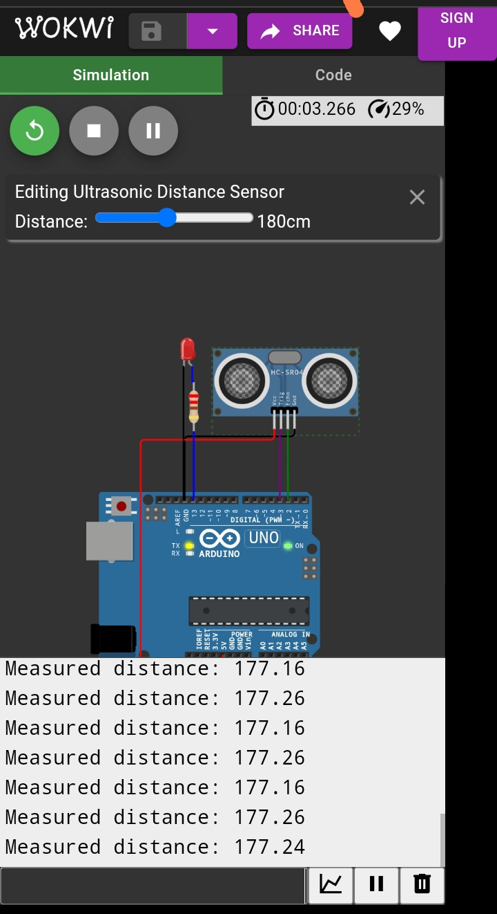

**When Distance is Below 100 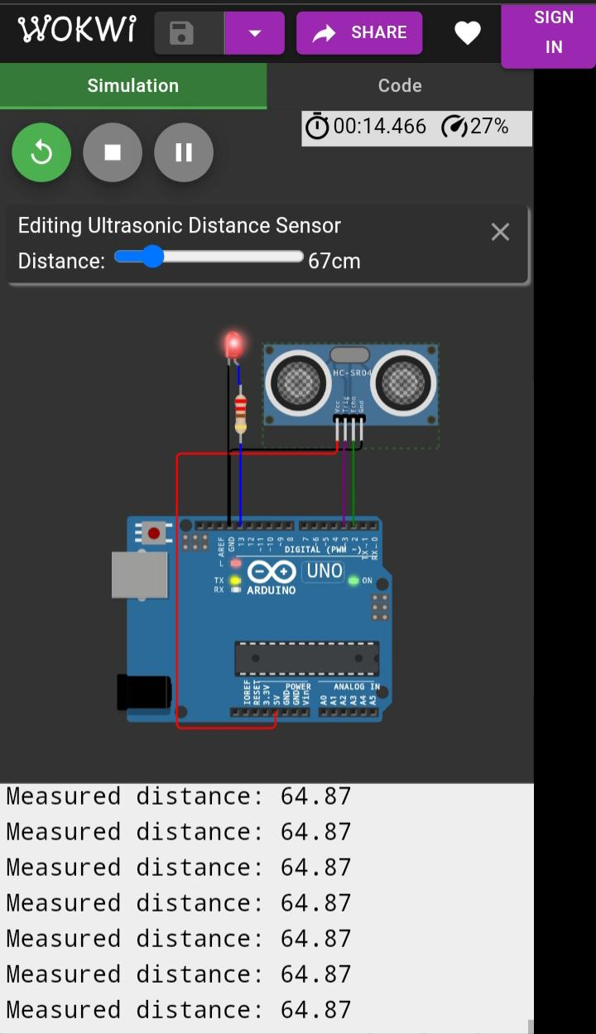CM**